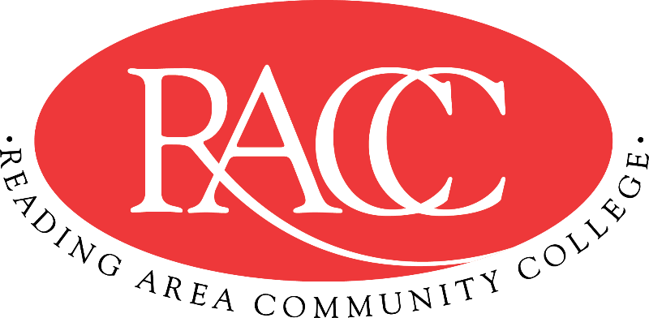

Transfer Guide
Reading Area Community College & Penn State Berks
A.A.S. in Criminal Justice |  |  | B.A. or B.S. in Criminal Justice
Course | Name | CR | Equivalent Course/ Area Satisfied | CR
CSS 103 | College Success Strategies | 3 | 3 cr. PSU xfrGEN | 3
COM 121 | English Composition I | 3 | ENGL 15 (GWS) | 3
LAW 135 | Introduction to Criminal Justice | 3 | CRIM 100 | 3
LAW 140 + LAW 200 | Criminal Law + Legal Procedure | 3 + 3 | CRIMJ 220 + 3 cr. CRIM xfrGEN  (Skills Enhancement) (by Substitution) | 6
Total Credits |  | 15 | Total Credits | 15
HIS 110 or HIS 115 | History of the United States I or II | 3 | HIST 20 (GH) or HIST 21 (GH) | 3
POS 130 | American Government | 3 | PLSC 1 (GS) | 3
LAW 146 + LAW 255 | Law Enforcement Systems + Law Enforcement & Community Relations | 3 + 3 | CRIMJ 210 + 3 cr. CRIM xfr200  (Skills Enhancement) (by Substitution) | 6
LAW 155 | The American Legal Systems | 3 | 3 cr. CRIMJ xfrGS1 (Elective) | 3
LAW 185 | Criminology | 3 | CRIM 12 (GS) | 3
Total Credits |  | 18 | Total Credits | 18
COM 151 | Fundamentals of Speech | 3 | CAS 100 (GWS) | 3
PSY 120 | Interpersonal Relations & Communications | 3 | 3 cr. PSYCH xfr000 (Elective) | 3
ENV 130 | The Environment | 3 | BISC 3 (GN) | 3
ART 201 | Art Appreciation | 3 | ARTH 100 (GA) | 3
LAW 165 | The Correctional Process | 3 | CRIMJ 230 | 3
Total Credits |  | 15 | Total Credits | 15
IFT 110 | Introduction to Information Technology | 3 | MIS 204 | 3
MAT 210 | Statistics | 3 | STAT 200 (by Substitution) | 3
LAW 245 | Community Corrections | 3 | 3 cr. CRIMJ xfr200 (Skills Enhancement) | 3
LAW 285 | Juvenile & Domestic Law | 3 | 3 cr. CRIM xfr200 (Skills Enhancement) | 3
LAW 180 | Crisis Intervention | 3 | 3 cr. CRIM xfrGEN | 3
Total Credits |  | 15 | Total Credits | 15
Total Credits |  | 63 | Total Credits Transferable | 63

This Transfer Guide is designed for Penn State Berks ONLY. Students seeking transfer admission to any other campus should contact that campus directly.
This Transfer Guide may change without notice before the student is admitted to Penn State Berks. RACC students should confirm their academic plans with the Transfer Admissions Counselor at Penn State Berks: 610-396-6462 or berkstransfer@psu.edu. Following this Transfer Guide does not guarantee admission or transfer of credit to Penn State Berks.

