New Orientation Leader Application
Penn State Berks Campus

NAME AS IT APPEARS ON STUDENT ID:

NAME ON NAME TAG:

ANTICIPATED GRADUATION:
( )
CELL PHONE:

PSU E-MAIL:

BIRTHDAY:

T-SHIRT SIZE:

MAJOR:

PSU ID#:

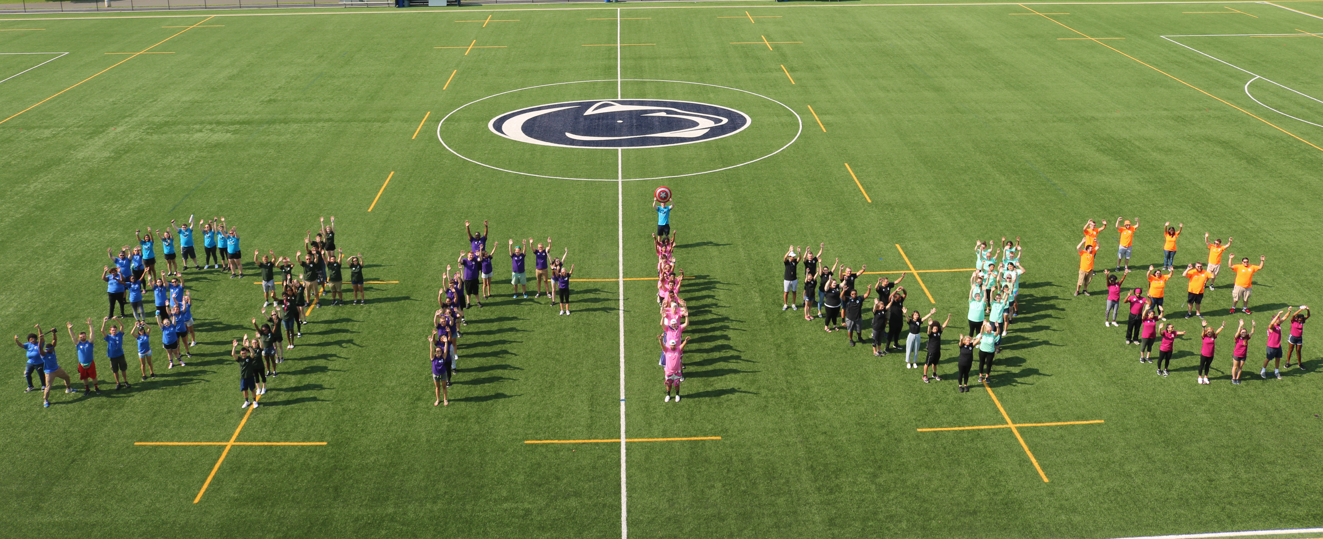
FALL 2019 SEMESTER, I PLAN TO LIVE:
___On campus
___Off campus at home ___Off campus not at home
If you are planning to live off campus, how long will your commute be?

Include ALL Social Media Names/Handles
(Include: Facebook, Twitter, Instagram, Snapchat):

SELECT WHICH TYPES OF OL YOU ARE INTERESTED IN:
See attached expectations for more information

____Serving as a regular OL ____Serving as a First Year Group Leader (FYGL)

Serving as a Mover and Shaker ____Serving as an Operations OL (OPPs)

IN THE SPACE PROVIDED, OR ON A SEPARATE SHEET, PLEASE ANSWER THE FOLLOWING:
- What excites you about becoming an Orientation Leader?
________________________________________________________________________________________________________________________________________________________________________________________________________________________________________________________________________________________
- List your current involvement with clubs, sports, community service, and other leadership roles at Penn State or outside of Penn State. Please include any major responsibilities and positions held. ________________________________________________________________________________________________________________________________________________________________________________________________________________________________________________________________________________________

- What leadership qualities do you possess? What leadership qualities could you improve upon?
________________________________________________________________________________________________________________________________________________________________________________________________________________________________________________________________________________________
- Looking back at your experience during Orientation/Welcome Weekend: 1- what activities did you enjoy? 2- What activities would you like to see added to the program to increase new student involvement? If you did not attend Orientation/Welcome Weekend: What would you suggest be done to increase participation?
________________________________________________________________________________________________________________________________________________________________________________________________________________________________________________________________________________________
- What advice would you give to new students about successfully adjusting to college life:
________________________________________________________________________________________________________________________________________________________________________________________________________________________________________________________________________________________

Return this application by March 1, 2019 at 5 p.m. to the Campus Life Office in 19 Perkins Student Center
Thank you for your interest in being an Orientation Leader. If you should have any questions concerning this application or about the responsibilities of an Orientation Leader,
please contact Autumn Fritz (amr40@psu.edu) or stop by the Campus Life Office or call 610-396-6076.
Please initial next to each statement:
____ The information that I have provided on this application is accurate and true to the best of my knowledge.
____ I understand that incomplete or inaccurate information may be grounds for disqualification from the Orientation process.
____ I authorize Campus Life to regularly review my academic and disciplinary records recognizing that this could impact my ability to continue in the Orientation Leader process.
____ I authorize the Welcome Weekend Leadership team to regularly review my social media presence, and understand this could impact my ability to continue in the Orientation Leader program.
____ I have reviewed all expectations of Orientation Leaders and plan to uphold them all.
____ I have reviewed all dates for necessary trainings and will be in attendance. If I am not able to do so, I will notify my Captain, the Lead Team, Brandon or Autumn at least 2 weeks prior.

Signed _____________________________________________________________ Date____________________

