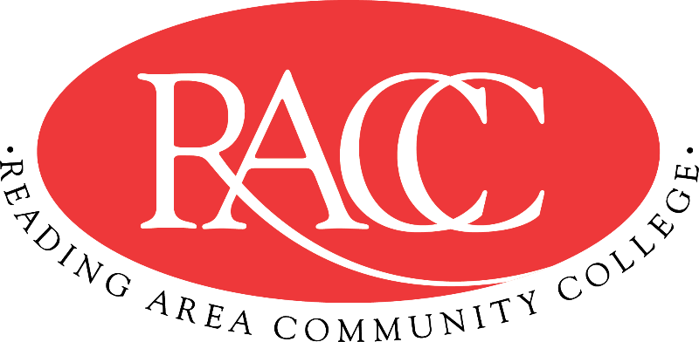

Transfer Guide
Reading Area Community College & Penn State Berks
A.A. in Psychology |  |  | B.A./B.S. in Psychology
Course | Name | CR | Equivalent Course/ Area Satisfied | CR
CSS 103 | College Success Strategies | 3 | 3 cr. PSU xfrGEN | 3
COM 121 | English Composition I | 3 | ENGL 15 (GWS) | 3
IFT 110 | Introduction to Information Technology | 3 | MIS 204 | 3
COM 221 | Business Communication | 3 | ENGL 202B (GWS) | 3
ART 201 | Art Appreciation | 3 | ARTH 100 (GA) | 3
Total Credits |  | 15 | Total Credits | 15
COM 151 | Fundamentals of Speech | 3 | CAS 100 (GWS) | 3
PHI 275 | Introduction to Ethics | 3 | PHIL 103 (GH) | 3
MAT 150 | Foundations of Math | 3 | MATH xfrGQ1 | 3
MAT 210 | Statistics | 3 | STAT 200 (GQ) (by Substitution) | 3
ENV 130 | The Environment | 3 | BISC 3 (GN) | 3
Total Credits |  | 15 | Total Credits | 15
General Education: Natural/Physical Sciences |  | 4 | General Education: Natural Science (GN) | 3
HIS 110 or HIS 115 | History of the United States I or II | 3 | HIST 20 (GH) or HIST 21 (GH) | 3
Elective |  | 3 | General Education: Arts (GA) | 3
PSY 130 | General Psychology | 3 | PSYCH 100 | 3
PSY 208 | Development Across the Lifespan | 3 | PSYCH 212 | 3
Total Credits |  | 16 | Total Credits | 16
PSY 230 | Abnormal Psychology | 3 | PSYCH 270 | 3
PSY 240 | Educational Psychology | 3 | EDPSY 14 | 3
PSY 235 | Social Psychology | 3 | PSYCH 221 | 3
PSY 270 | Research Methods in Psychology | 3 | PSYCH xfrGEN (PSYCH Elective) | 3
PSY 245 or PSY 250 | Biological Basis of Human Behavior or Sensation and Perception in Psychology | 3 | 3 cr. PSYCH xfrGEN or  3 cr. PSYCH xfrGEN | 3
Total Credits |  | 15 | Total Credits | 15
Total Credits |  | 61 | Total Credits Transferable | 61

This Transfer Guide is designed for Penn State Berks ONLY. Students seeking transfer admission to any other campus should contact that campus directly.
This Transfer Guide may change without notice before the student is admitted to Penn State Berks. RACC students should confirm their academic plans with the Transfer Admissions Counselor at Penn State Berks: 610-396-6462 or berkstransfer@psu.edu. Following this Transfer Guide does not guarantee admission or transfer of credit to Penn State Berks.

