Penn State Berks Common Reading Program/CACE
^{4th} Annual [Virtual] Book Drive
Benefitting the
Migrant Education Program in the Reading Area School District

Accessible October 22 through November 4 at the following URL: https://www.scholastic.com/bf/psuberksmepbookdrive2021
Consider following the URL to purchase books appropriate for students in 5th and 6th grade at our local MEP, who are learning English as their second language to nurture their love for reading.

On the order form, it will ask you where the books should be sent.
Please complete that section using the following information:
Tatiana Garzon-Toro
Migrant Education Program
800 Penn St., Reading, PA 19602.

We are…promoting a love of learning in our area

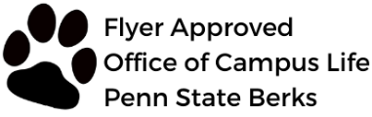
The 2021 Penn State Berks Common Reading Program is sponsored by Barnes & Noble Education.

