CAS100 Video Project
Dawn Pfeifer Reitz | Catherine Dunning Catanach
2019-2020

Introduction
In response to a call from the CLT team at Berks for the Teaching & Learning Innovation Partnership Program, Professor’s Catanach and Reitz submitted a joint project to update and produce video for our CAS100A Effective Speech courses. Our goal was to update and refresh content and to provide our students with the opportunity to watch and re-watch videos to consume and review content in their own time. This report will detail the experiences of Professors Catanach and Reitz.

Our courses run in a “flipped classroom” approach. Flipping the classroom allows students to learn content on their own time, and then apply content during our classroom sessions. Providing students with a set of short, easily digestible videos with consistent messaging about the topics allows the students to review materials in small chunks. Allowing students to watch and re-watch these delivery videos allows students to learn at their own pace and consume the materials repeatedly.

Catanach produced two videos on persuasion for the course.

Reitz took a series of four videos from a prior institution and worked with CLT to update/reboot these videos and make them more streamlined and relevant to today.

Project Design
Once our project received approval, we met with the CLT Team to discuss the goals of the program, then had subsequent meetings with Mary Ann Mengel, the lead for our project. We each broke our projects down to manageable chunks complete with a timeline, deadlines, and storyboards. We worked to create and record scripts and planned and videoed various content through the Spring and Summer of 2019.

Learning Outcomes
Providing students with a set of short, easily digestible videos with consistent messaging about the topics allows the students to review materials in small chunks. Allowing students to watch and re-watch these delivery videos provides them an opportunity to learn at their own pace and consume the materials repeatedly.

Catanach’s students preferred the video to the online book in that they were entertaining, quick and to the point.

Reitz’s students anecdotally reported repeated viewings of the videos, and a sense of comfort in being able to watch the videos at their own pace.

Here is a sample of qualitative comments from the survey:
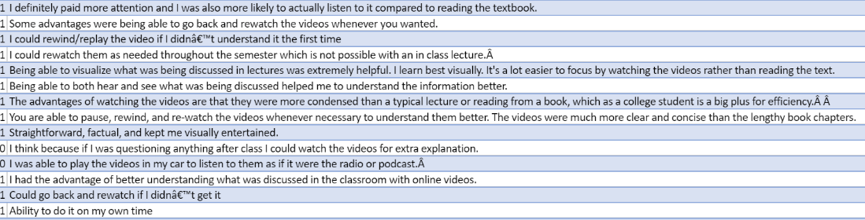

Additionally, some students indicated that they had a slight frustration that they were not able to immediately ask questions if they had them while watching the videos. A few students indicated that they do not enjoy learning content in an online modality.

Discussion
Thanks to Ms. Mengel, Catanach and Reitz were able to insert surveys into all sections from Fall 2019 that utilized the updated videos. The feedback received from these surveys was overwhelmingly positive and in support of the project.

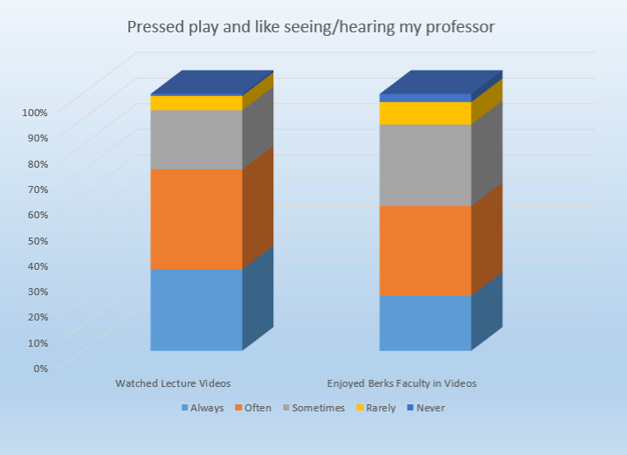
Questions:
- I watched the lecture videos created by Professors Reitz and Catanach.
- Seeing and/or hearing from Berks faculty in my course videos is important to me.

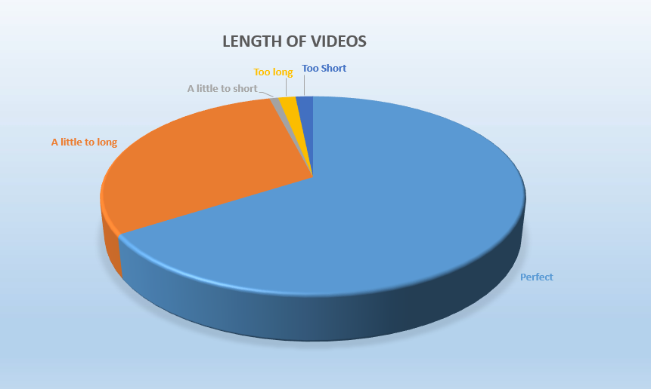
Questions:
- On average, the length of the professors' videos was: When considering my ability to learn by watching a video-based online mini-lecture vs from a short lecture in the classroom, I learn best from:

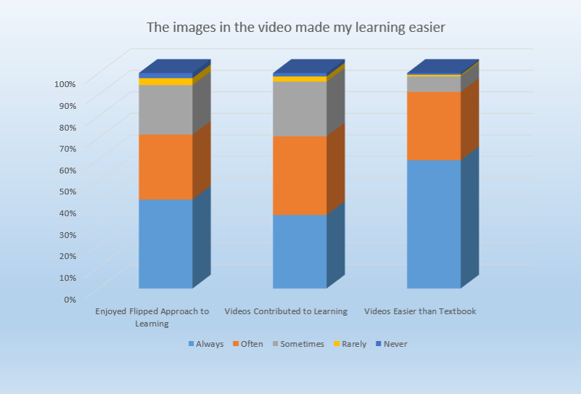
Questions:
- I enjoy the flipped approach to learning used in CAS 100A which gives me the flexibility to learn content on my own time and focus on activities other than lecture during class meetings.
- The online mini-lecture videos in which the Berks professors elaborated on readings and topics contributed to an effective learning experience in this course.
- Watching videos about the course topics makes learning easier than reading a textbook alone.

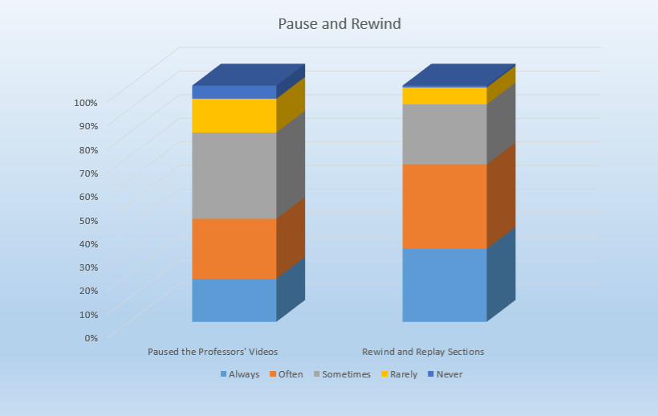
Questions:
- Sometimes I paused the professors' videos to process what was said or to take notes.
- I took advantage of the ability to rewind and replay sections of the professor's video to make sure I understood, or to review.

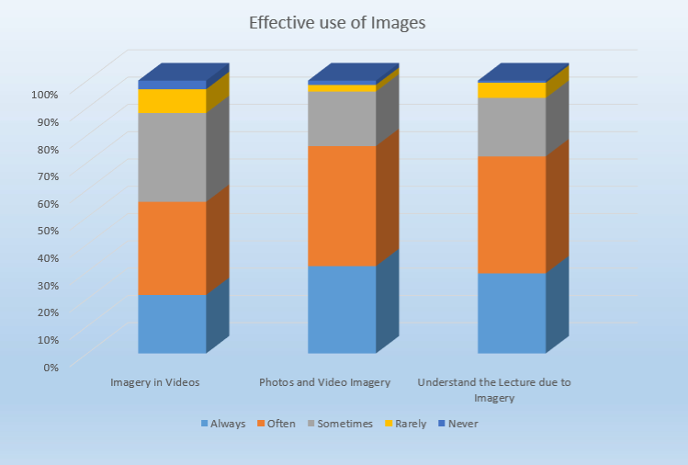
Questions:
10. The imagery in the videos helped me feel an emotional connection with the topics discussed. It was easier to understand the lecture topics because the imagery in the videos communicated layers of meaning beyond what is usually possible with in-class lecture techniques.
11. The photos and video imagery in the professors' videos helped me to better imagine the situations and topics described.

12. It was easier to understand the lecture topics because the imagery in the videos communicated layers of meaning beyond what is usually possible with in-class lecture techniques.

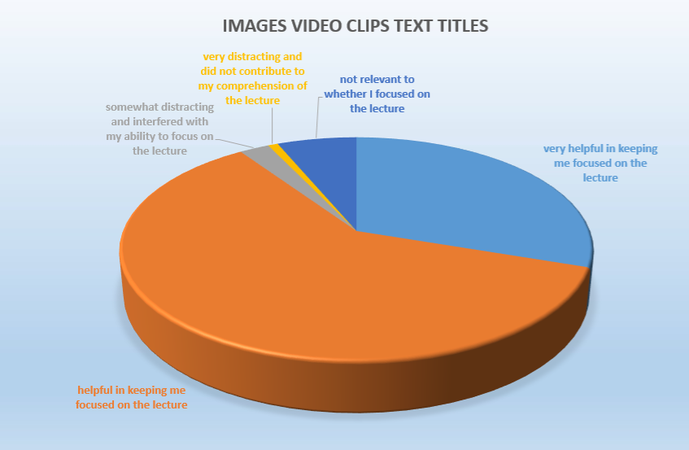
Question:
13. The images, video clips, and text titles in the professors' videos were.

Comments and Responses:
- Some students indicated that they had a slight frustration that they were not able to immediately ask questions if they had them while watching the videos.
  - Catanach and Reitz agree that we should identify a mechanism for addressing questions that come up from the videos in a more formal way. One idea we have is to incorporate a discussion board that can be facilitated by our Peer Mentors that can serve as a place to pose questions and answers to the videos.
- A few students indicated that they do not enjoy learning content in an online modality.
  - Even though our courses are formally listed as “and web” which is the PSU indicator of a hybrid course, Catanach and Reitz can consider sending reminders via LionPath to students to indicate that our particular sections are hybrid modality and that online work is a requirement.

Scholarly Outcomes
Catanach and Reitz have no plans to prepare any scholarly pieces regarding this project. However, in Summer 2020 this project will be the focus of a presentation they are co-presenting at the TLT Summer Series, which replaces the annual TLT Symposium at Penn State University. This presentation, entitled #BrandYourCourse: Bridging the Gap from Textbook to Classroom, provides insight into how Teaching and Learning with Technology resources were effectively merged with old fashioned creativity to bridge the gap from the textbook to the classroom and beyond through engagement in a hybrid General Education course. The discussions will elaborate on the use of an open-source textbook, videos that were created to supplement textbook content, and how social media was leveraged to engage students. Attendees will learn how these strategies could be used in other disciplinary contexts.

Recommendations
This project was an effective use of resources. Catanach and Reitz were able to take a concept in their heads and implement it through discussion with the CLT staff. Others considering this approach should feel confident in the CLT staff’s expertise and should work with them with an open mind, in order to effectively complete the task. Others should not be afraid to think broadly and creatively and should not be deterred if an immediate solution is not presented. The creative thought and research of the CLT has found multiple creative solutions to implement even the most challenging of ideas.

Conclusion
This project was met with such success that both faculty members have been awarded a second round of TLI grants for the next cycle. Due to budget constraints, both Catanach and Reitz have not received compensation for these projects.

Acknowledgements
Professors Catanach and Reitz wish to thank Mary Ann Mengel and Amanda Martin for their diligence and creativity in guiding us through this project. Their vision and expertise were unwavering. The PSU Berks CLT Team is a gem on campus.

Works Cited
None

