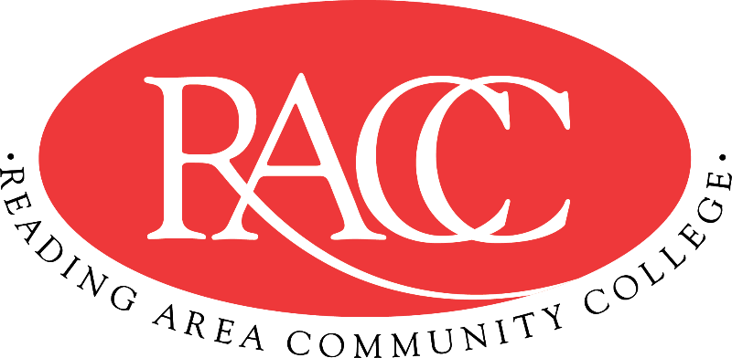

Transfer Guide
Reading Area Community College & Penn State Berks
A.A. in Creative Writing |  |  | B.A. in Writing and Digital Media
Course | Name | CR | Equivalent Course/ Area Satisfied | CR
CSS 103 | College Success Strategies | 3 | 3 cr. PSU xfrGEN | 3
COM 121 | English Composition I | 3 | ENGL 15 (GWS) | 3
IFT 110 | Introduction to Information Technology | 3 | MIS 204 | 3
COM 221 | English Composition II | 3 | ENGL 202B (GWS) | 3
General Education: Humanities |  | 3 | General Education: Arts (GA) | 3
Total Credits |  | 15 | Total Credits | 15
MAT 150 | Foundations of Mathematics | 3 | MATH xfrGQ1 (GQ) | 3
COM 151 | Fundamentals of Speech | 3 | CAS 100 | 3
ENG 125 | Introduction to Literature | 3 | ENGL 1 (GH) | 3
General Education:  Natural/Physical Sciences |  | 3 | General Education: Natural Science (GN) | 3
General Education:  Social Sciences |  | 3 | General Education: Social and Behavioral Science (GS) | 3
Total Credits |  | 15 | Total Credits | 15
COM 211 | Poetry Writing | 3 | ENGL 213 (Supporting Courses) | 3
COM 215 &  COM 216 &  COM 218 | Creative Nonfiction  Creative Nonfiction II  Fiction Writing I | 9 | ENGL 214 &  6 cr ENGL xfrGEN | 9
General Education:  Social Sciences |  | 3 | General Education: Social and Behavioral Science (GS) | 3
Total Credits |  | 15 | Total Credits | 15
COM 110 | Introduction to Creative Writing | 3 | ENGL 50 | 3
COM 125 | Publishing Practicum: Editorial Process | 3 | COMM xfrGEN (Supporting Courses) | 3
COM 219 | Fiction Writing II | 3 | ENGL 212 | 3
COM 126 | Publishing Practicum: Design and Production | 3 | COMM xfrGEN (Supporting Courses) | 3
General Education:  Natural/Physical Sciences |  | 4 | General Education: Natural Science (GN) | 4
Total Credits |  | 16 | Total Credits | 16
Total Credits |  | 61 | Total Credits Transferable | 61

This Transfer Guide is designed for Penn State Berks ONLY. Students seeking transfer admission to any other campus should contact that campus directly.
This Transfer Guide may change without notice before the student is admitted to Penn State Berks. RACC students should confirm their academic plans with the Transfer Admissions Counselor at Penn State Berks: 610-396-6462 or berkstransfer@psu.edu. Following this Transfer Guide does not guarantee admission or transfer of credit to Penn State Berks.

