TLI Grant Report
Jennifer Dareneau
2017

Introduction
In my online ENGL 202D classes, I previously had a word document that served as the highlights from the chapter. There are 15 chapters total in the semester. After students read the chapter, and reviewed my highlights, they took a quiz and completed a case study/individual writing assignment based on that chapter. For example, they read the chapter on applying for employment, and they composed a cover letter and resume for that week. The problem I found is that students were not always receiving full credit on the quizzes, which are open note, open book and have only 5-10 questions, and they were missing key formatting and content/ message patterns in the individual assignments. This indicated to me that students were either not reading the chapters or that they were not able to understand the most important points from the chapters. In my face to face classes, this was not often a problem, and I thought that it might be because I could discuss the chapters in person in lecture form/ presentations on the overhead and cover those points, as well as address common mistakes students had made on the projects in the past. I applied for a TLI grant because I wanted the online class to be more engaging and less text based, as well as up to date. I wanted to see better understanding of the assignment objectives and formatting.

Through consultation with Mary Ann Mengel, our solution was to convert the highlights to presentation slides and then record myself in a video and do a screencast as I review the notes and the assignments. Previously, other than the welcome video and a couple screencasts of me reviewing a document (and I do not appear; it's just a voiceover), students did not see me or hear me present the information because it's all done through written descriptions. Ensuring accessibility was also a big part of this, since the lecture videos were newly created. The previous ENGL 202D WEB classes were all created in ANGEL and then brought over to Canvas, so we also wanted to look at ways to utilize the strengths and special features of Canvas for the class as an update.

Project Design
1. Converted word doc of Chapter Highlights to Prezi format
The following chapters were converted:
Ch 1 Achieving Success Through Effective Business Communication
Ch 2 Mastering Team Skills and Interpersonal Communication
Ch 7 Crafting Messages for Electronic Media
Ch 11 Finding, Evaluating, and Processing Information
Ch 10 Writing Persuasive Messages
Ch 8 & 9 Writing Routine and Positive Messages and Writing Negative Messages
Ch 18 Building Careers and Writing Resumes
Ch 19 Applying and Interviewing for Employment
Ch 12 Designing Visual Communication
Ch 13 Planning Reports and Proposals
Ch 14 Writing Reports and Proposals
Ch 15 Completing Reports and Proposals

I did not include chapter number in the prezis themselves so that if I switch textbooks or editions, I will still be able to use the prezis without editing them.

2. Recorded screencasts of all prezis with lecture
I used Screencast-o-matic to do this and uploaded all videos to my Youtube channel. Screencast-o-matic allows for picture within picture presentations so I accessed both the screencast and webcam function. The slides appear as the larger screen and my webcam video appears in the lower right corner. I was able to keep all videos around 10 minutes in length.

3. Captioned all new and existing videos
I needed a lot of help with this. Mary Ann Mengel and her interns were able to do the captioning on the Youtube videos. I reviewed and edited their captions, and then approved them to be used.

4. Created pages for each week, include links to activities and videos
I created basic pages with information about the week’s objectives and links to the lecture video, the quiz, the discussion group, and the individual assignment.

5. Cleaned up all modules and moved resources into assignment description
Rather than having multiple links in a list, I moved all links to news videos, articles, templates, word docs, and webpages into the assignment.

6. Created mid-semester survey
With frequent help from Mary Ann and her interns, Qualtrix was used to create a mid semester syllabus quiz to gauge student response to the new format. We edited the language of the questions and possible answers several times before publishing it to the course.

7. Converted video discussions from YouSeeU to Canvas.
Due to a number of issues with YouSeeU’s video platform over the last year, I decided to switch to Canvas’ group discussion function instead, and enabled it for video use to mimic YouSeeU’s platform. I created all these as new assignments/ discussions since they did not exist in Canvas previously.

Learning Outcomes
All tables provided by the Center for Teaching and Learning based on the survey administered in the online class. During mid-semester of Summer 2017, students in the online course were surveyed about the various topics of both the online course method and the instructor’s teaching style. The results are displayed in table and graph form, please see the appendix at the end of the report.

The majority of students rated all of the online components as above average or excellent, with a few students rating them as average. This rating pattern holds true for all questions asked of the course including the video lectures, homework assignments, video lectures, and the course as an online class overall. Q8 from the survey “What did you like best about the course?” elicited answers such as:
- I really enjoy the group discussions and learning from the video lectures.
- Thus far I am very happy that videos are a large portion on the course. Seeing my peers talk about he same subject is very helpful.
- I love how relative this course is to my life right now. Everything that I am learning is such relevant information that I not only need to know at this point in my life, but for any future career. I love how self-explanatory all of the assignments and instructions are.
- The course is constructed very well, it contains everything we need to know in business writing. The discussion posts make the course a good learning experience.
Similar responses were given for Q9 - What are the best qualities of your instructor’s teaching style in this course?
- The clear instructions and very helpful video lectures.
- I enjoy her YouTube videos that give a quick rundown of the important stuff in the chapter
- I believe the professors ability to clearly layout the courses requirements via solely online formats.
- The videos are very helpful as well as in depth instructions. An online class can be difficult especially one with this much material. However, the set up of this course is effective.

Discussion
The video responses and student feedback utilize media literacy skills in the online class and provided students with a new (to them) take away skill that they might not be learning in other classes, especially those that meet face to face. The video assignments have successfully replaced some of the written group activities and individual activities, and work exceptionally well to replace in-class presentations. The skills that students learn by creating the videos and giving feedback are useful and timely skills needed by today’s college graduates. This new iteration of the student videos, and the addition of my own video lectures created an opportunity to both model the type of communication techniques used in professional/ informal videos online and to create instances of practice that successfully mimic workplace and internship communication and situations.

Furthermore, one indictor of the success of the new instructor video lectures was an uptick in quiz grades. Please see below for course quiz averages over the last year:

In ANGEL
Summer 2016 summer 1 section 40 90.39%
Summer 2016 summer 1 section 41 91.93%
Summer 2016 summer 2 section 50 91.88%
Summer 2016 summer 2 section 51 94%
Summer 2016 all classes quiz score average: 92.05%

In Canvas
Fall 2016 section 1 85.85%
Fall 2016 section 2 90.34%
Fall 2016 all classes quiz score average: 88.095%

Spring 2017 section 1 92.98%
Spring 2017 section 2 95.03%
Spring 2017 section 7 87.32%
Spring 2017 all classes quiz score average: 91.77%

In Canvas, TLI modified version
Summer 1 section 40 94.38%
Summer 1 section 41 95.63%
Summer 2017 all classes quiz score average: 95%*
*At the time of the report, there were two sections of ENGL 202D online in progress, so those quiz score averages are not yet available.

The course quiz grade averages do show an improvement over the previous semester, before the changes were implemented in course design and the video lectures made available. However, I would not say that the data shows an exact comparison due to the fact that the majority of my spring students were 4th semester Berks campus students, and the summer class, the majority is made up of 6th semester UP students. Also, the regular semester is 16 weeks long, and the summer class is 6 weeks long, which presents more of an immersion model for the class pace, and it’s possible that my class was the only class students were taking, where that would not be the case in the spring semester. Nevertheless, no questions on the quizzes were changed in the last year and student quiz grades improved overall.

Feedback to course from students has been positive. I have received several unsolicited emails and notes from students in the summer course, expressing their satisfaction with the course and my teaching. SRTE would not be an indicator for class satisfaction due to the low number of students completing them (only 5-10 students per section that enrolls between 24-30 students). Better student participation was found with the mid-semester qualtrix survey, which was discussed above and results are located at the end of this report.

Unsolicited Student Emails all from Summer 1 2017:
June 23, 2017 at 2:52am
Thank you! I really learnt a lot in the course! So much practice helped me and the feedback for each was what that was needed!

Jun 23, 2017 at 12:03am
Thank you for a great semester. I really learned a lot from this course and sincerely believe that if I had not taken this course, I would have been extremely unprepared for the professional world. I really do appreciate your help and feedback! Take care.
Jun 21, 2017 at 2:52pm
Thank you for teaching this course. One of the most beneficial and useful classes I've taken at Penn State!

June 23, 2017 4:24 pm
I had a great experience taking this course. Thank you and have a great summer.
May 29, 2017 10:11 pm
Dear Professor Dareneau,
Hope you are doing great! I just wanted to let you know that your Individual grade comments help me improve and motivate me to write better. I really appreciate you giving personal feedback and specific reviews as I know that not a lot of professors so that! Thank you for that :)

May 30, 2017 1:33 am
Dear Professor Dareneau,
I really appreciate the time you take out to give us feedback on all our work. It really helps when I do work in the future.
Scholarly Outcomes
Although I do not have any published material related to my work with online education, I am cited as a resource by my division head, and have met individually with faculty from CAS, ENGL, and PW about the structure and creation of the online classes. I also run a workshop on assessing student writing every spring as a part of the Writing Across the Curriculum committee, and many of the strategies I use as a part of my online classes are discussed.

Recommendations
1. Although I was initially skeptical of the talking head video, I made it picture within picture instead, with slides, and students have responded well to having the videos. It creates a personal connection with the professor, even if it isn’t in real time. They were a good idea, and I wish I had made them for previous classes.
2. Allot double the amount of time you think it will take you, especially if you plan to use any videos in the class. Creating the slides and the video itself only takes about an hour, but uploading the videos to YouTube and captioning the videos takes much, much longer.
3. Many of the suggestions from the TLI committee were ones I had not heard of, and I was very nervous to implement or change too much in the course. This was a mistake. I should have trusted that I would be well supported and should have recognized that several options were being offered, and I was not expected to use all of them. We were looking for a best fit for the problems I was having. Instruction and discussion for each resource and solution offered was clearly explained, and in some cases, screencasts or instruction sheets provided to help me, and face to face meetings were always offered.

Conclusion
The class works. This is a better, more effective version of the online class. Students are pleased with the layout and content, as well as the delivery and feedback given to them. Face-to-face interaction in a traditional class has been successfully replaced by video lectures and video discussion groups in this online version. The students can work at their own pace while adhering to deadlines, and still have an opportunity to “see” the instructor and their classmates weekly, which has eliminated the feeling of isolation experienced by some students in some online courses. The instructional videos are being watched, and student quiz grades are up for the summer, as compared to previous semesters.

Acknowledgements
Mary Ann Mengel has been indispensable throughout this process, as have her interns. She spent time locating resources for me to use, then explained them to me, and then created either a screencast or an instruction sheet showing me how to use them. Several student resources were created for use in my class (and Tara Beecham’s) that dealt with student use of the video discussion groups, as well as posting to the discussion groups. Mary Ann was also a huge help in the captioning process for all of these new videos.

Appendix

Figure 1: Clarity and Expectations
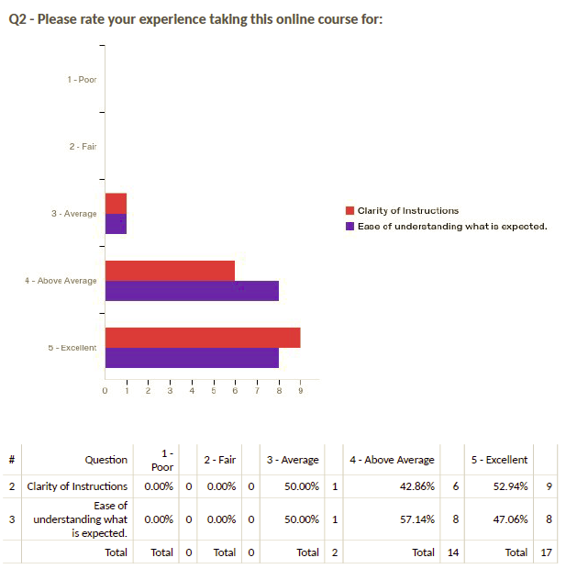

Figure 2: Effectiveness of Homework
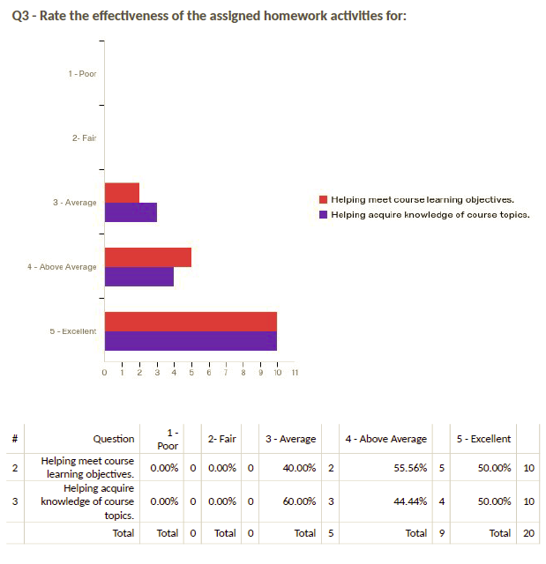

Figure 3: Effectiveness of Instructor's Videos
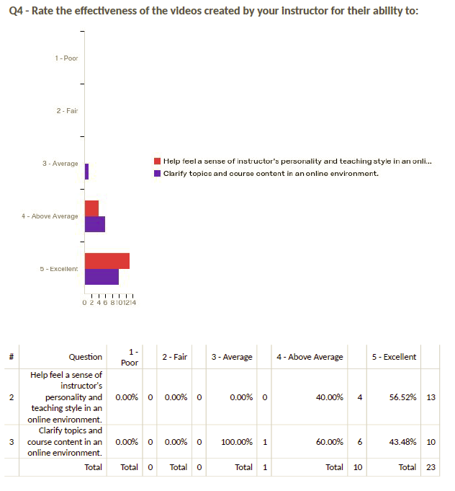

Figure 4: Effectiveness of Peer Videos
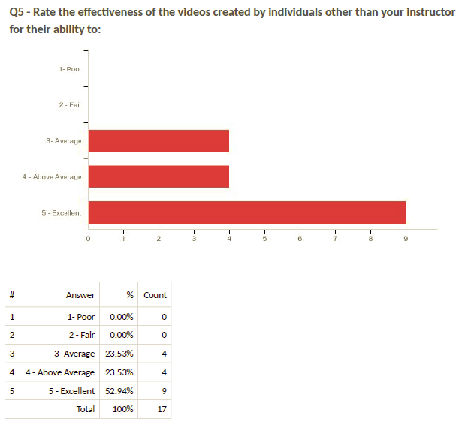

Figure 5: Value of Video-based discussion with peers
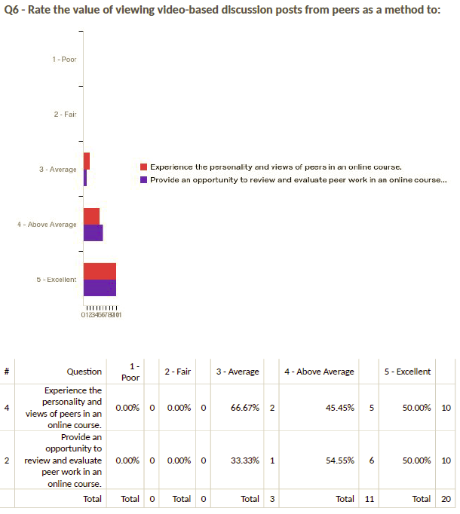

Figure 6: Value of sharing video-based discussion posts
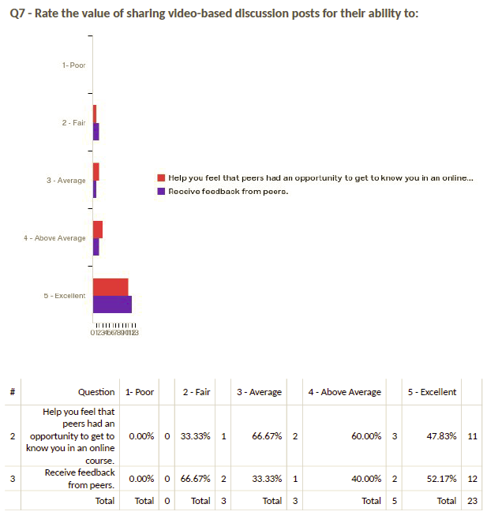

Figure 7: Best aspect of course
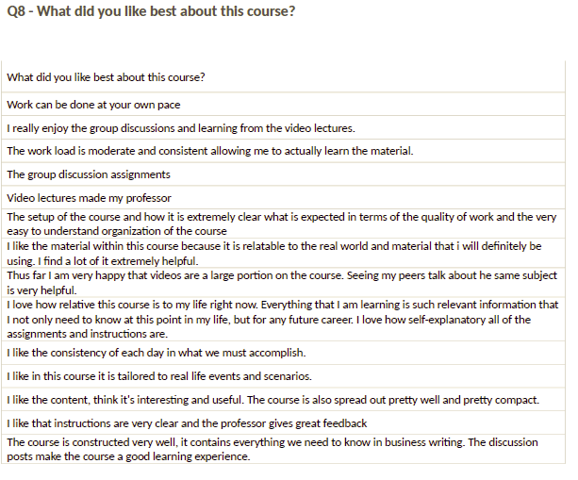

Figure 8: Best qualities of instructor’s teaching style
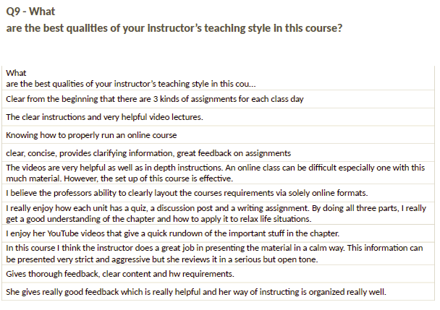

Figure 9: Suggestions for improvement
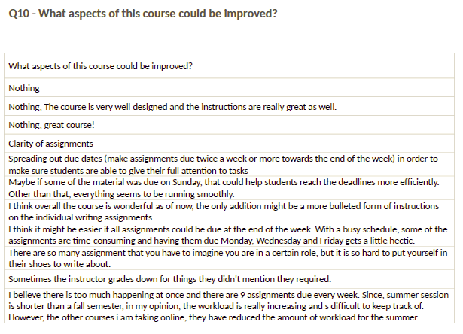
Figure 10: Suggestions for improvement
