MCHT111: Mechanics for Technology: Statics Faculty Name: Dr. Marietta Scanlon
Year(s) of Project: Spring 2016 – Summer 2017

Introduction
MCHT 111: Statics is a three credit course that is typically offered to Electro Mechanical Engineering Technology (EMET) majors entering their second semester. The course has historically been delivered in three 50 minute face-to-face sessions. A typical 50 minute session generally consists of about one-half lecture and one-half problem solving. The greatest challenge that affects the course is the wide discrepancy in the student’s rate of understanding the material and problem solving methodologies. Some students understand and complete a problem in a matter of minutes, while others need significantly more time, and a balance must be struck between providing the slower students with a thorough understanding while also addressing the needs of the more advanced students.
The goal of this project was to hybridize the course so that in-class meetings can focus more on delivering the content while the problem-solving aspect can be explained and practiced more effectively using an online delivery method to allow students to work problems at their own pace. This grant allowed for the creation of the resources necessary for students to participate at their own pace and thereby customize, individualize and optimize their learning process.

Project Design
An initial meeting was held to review the scope of the project and establish a timeline. Following that initial meeting, a more specific introductory meeting was held with Mary Ann Mengel, Instructional Multimedia Designer, who served as the project manager for the grant. At this initial meeting, we discussed the general objectives and how to best achieve them. The main objective was the creation of resources to enhance student learning through problem - solving, so it was determined that the first steps would be to design a plan and approach beginning with a list of topics which students often struggled with, associated questions to be asked, and to explore the various software options to determine which would work the best for delivery. Mary Ann presented a variety of options, including Adobe Captivate, Adobe Presenter, Camtasia, Doceri and Screencast-O-Matic. Each program had advantages and disadvantages, for example, Adobe Presenter and Captivate allow for the creation of figures and visuals for each diagram and the ability to create a more interactive experience, however the learning curve is difficult and problem creation is time-consuming. Doceri, and Screeencast-O-Matic allow for an easier interface to create problems, however it’s more difficult to incorporate question sets within the problem.

An initial sample exercise was created using Adobe Captivate. This problem was evaluated for several attributes, including ease of creation, impact of problem-solving experience and student engagement. Screenshots of this sample problem are shown in Figure 1.

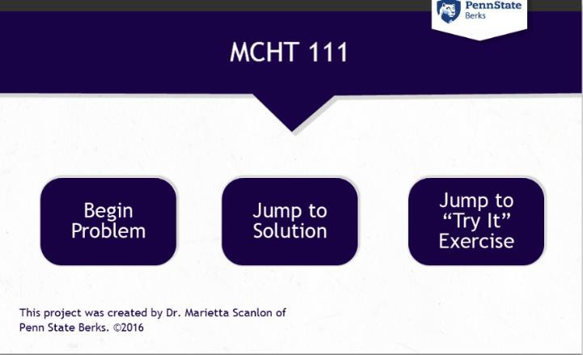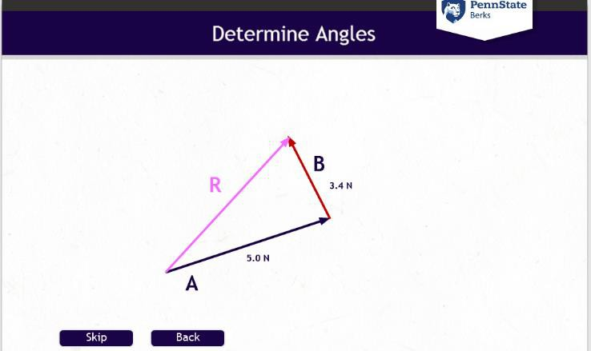

Figure 1: Screenshots of example problem designed using Adobe Captivate

Before moving forward using Adobe Captivate, this initial example problem was presented to several students for testing, to determine whether to continue with this methodology.
Although the problem had a professional, clean interface, and allowed for students to be actively involved in the problem-solving process, most of the student feedback was negative. The majority of comments indicated that the problem did not hold their attention and moved too slowly. Based on that, combined with the complexity of the development process we made the decision not to use Captivate for this project.

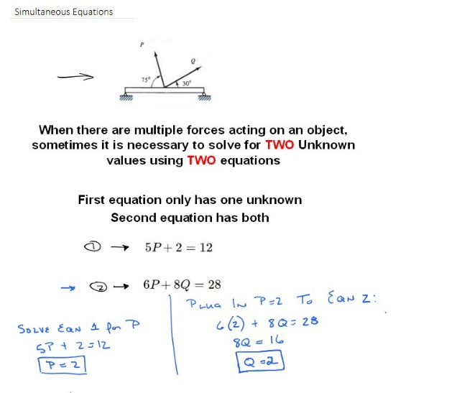
After exploring all of the other options, it was determined that the best course of action would be to create videos using Microsoft Onenote on a Surface Pro tablet, and record those videos using Screencast-O-Matic. This pairing allowed for directly relating online content to the material covered during the week in a way that held the students’ attention, allowed for emphasis of important subtleties within the problem, as well as allowed for students to easily either replay or fast-forward through content as necessary. Student interns close-captioned all of the videos. A screenshot of a finished example is shown in Figure 2.

Figure 2: Screenshot of problem created using OneNote and Screencast-O-Matic.

In addition to video resources, we also wanted to incorporate a way to hold the students accountable for reviewing the material, provide opportunities for self-check, as well as to evaluate student learning. For this, a series of quizzes that directly related to the content for the week were developed in Canvas. The intent was that students would take the quiz after completing all of the weekly requirements. As part of the project, we also investigated ways to integrate questions into the video by utilizing the H5P plug-in for Sites, made available through a PSU pilot program, and embedding the interactive video content in Canvas. This plugin allowed for the incorporation of questions into the flow of the video, serving as an instantaneous check for understanding. This technique was very successful, and received positive feedback from the students, however support for the plug-in was not incorporated into Sites@PennState, and all content developed during the pilot is no longer available.

Accessibility requirements were adhered to with the help of both Mary Ann and student interns. Mary Ann created a Canvas home page for the course that was both visually pleasing as well as accessible. Modules were re-designed to ensure a consistent look as well as satisfy accessibility requirements. The flow of the modules prior to this project were such that the information was very linear and the student had to scroll down the page to access all content. The new modules are redesigned so that all of the content is visible and there is a clear identification of in-class vs online work. The major improvements to the module overview pages can be seen in Figure 3.
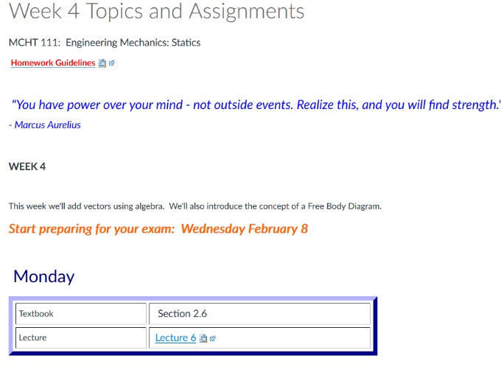
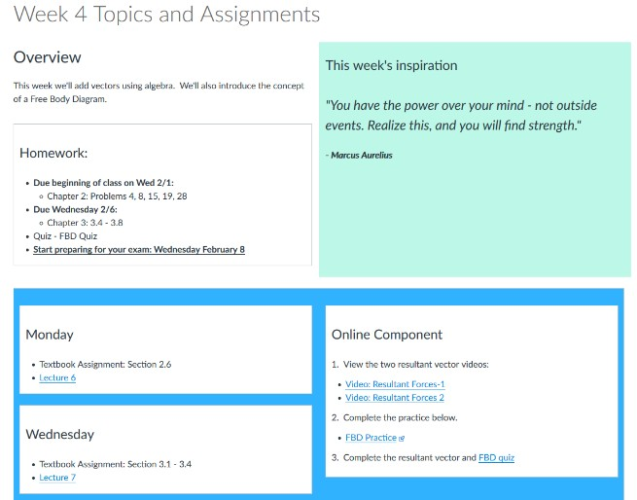
Figure 3: Initial module lay-out vs. re-designed module.

Implementation and Learning Outcomes:

A beta version of the hybrid course was deployed in the spring 2017 semester. This version utilized video examples that were created using OneNote and Screencast-O-Matic, Canvas quizzes, and the initial module lay-out as indicated in Figure 3. To assess student learning and opinions, an assessment was created in Qualtrics and administered to the students at the end of the semester. Based on student response, additional changes were made to the course to create the final version.

Students were queried with respect to course content as well as delivery method. Some questions utilized a 5 point Likert Scale, where 1 = Strongly Agree and 5 = Strongly Disagree. The mean and standard deviation of those questions are shown in Table 1.

Table 1: Student responses to survey questions.
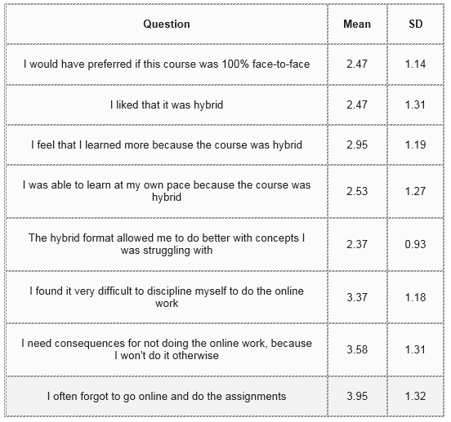

In addition, several open-ended questions were asked, and responses were used as recommendations for redesign. Responses are summarized in Table 2.

Table 2: Summary of student responses to open-ended questions.
Question | Response Summary
How did you make use of the online problem-solving videos? | - If I was having trouble with a concept, I watched the same video multiple times.  - I fast-forwarded through the videos until I got to the specific spot I was having trouble with.  - I watched them all the way through whether I understood or not.
How might the online videos be improved? (choose all that apply) | - No changes, I was happy the way it was  - Make them more interactive  - Include more of them  - Add "check-points" throughout where you have to answer questions

Discussion

As can be seen from the assessment results, the hybridization of the MCHT 111 course was a great success, especially because the data collected was based on assessment prior to completion of the course redesign. The survey responses offer a great deal of insight into what worked and what needed improvement for the course, and those suggestions have been utilized to complete the project successfully. The data from Table 1 indicate essentially equal opinion as to whether the student preferred a hybrid or face-to-face model, with much of the dissatisfaction of the hybrid model stemming from the nature and quantity of video problems. This is quite easy to improve upon, and therefore we believe that with modifications implemented, the satisfaction level with the hybrid course will increase. What was quite clear from the assessment results is that students felt that they were able to learn at their own pace and to do better with concepts they were struggling with. They were able to utilize the videos in a way that was beneficial to them, and thus were able to customize their learning. A major goal of this project was to be able to individualize the learning process, and clearly this was accomplished.

Several changes were made to the course based on the survey results. More videos were added, and a variety of difficulty levels were introduced. This results in a large database of videos of varying difficulty, which will further enhance the individualization of the learning process. A major request from the survey was the addition of check-points. The complicating factor during the course of this project was that the technology did not keep pace with our requirements. H5P appeared to be a viable solution, but the plug-in was ultimately not incorporated into Sites@PennState. Since interactive video introduces substantial learning benefits for this project, we are currently investigating the use H5P in Pressbooks to be able to insert questions within the flow of the videos. This will make the videos more interactive and allow for more direct evaluation of student learning.

Recommendations

For anyone considering implementing a similar approach, it is my recommendation that you start by evaluating the available software to determine what best fits your needs. In addition, any methods that allow for customization and/or individualization of the learning process will be highly valued by the students.

Conclusion

The goal of this project was to hybridize MCHT 111 so that lectures focused on theory and content, while the online portion was spent on problem-solving and individualized study, allowing students to work at their own pace and self-evaluate their progress. Videos were created using a Microsoft Surface tablet and Screencast-O-Matic, and student learning was assessed through online quizzes. Intermediate assessment indicated the students were interested in more video problems, more difficult problems, as well as active check-points during the videos. These suggestions for improvement were incorporated, and additional software capabilities are being evaluated to further enhance the course. Based on the successful development of course materials, as well as positive assessments, the project resulted in the successful hybridization of MCHT 111 and a course that allows for students to learn at their own pace and thereby customize, individualize and optimize their learning process.

Acknowledgements
This work could not have been accomplished without the assistance of Mary Ann Mengel and the student interns. Her guidance, expertise and advice was instrumental to the successful evaluation and completion of the project.

