Returning Orientation Leader Application
Penn State Berks Campus

NAME AS IT APPEARS ON STUDENT ID:

NAME ON NAME TAG:

ANTICIPATED GRADUATION:
( )
CELL PHONE:

PSU E-MAIL:

BIRTHDAY:

T-SHIRT SIZE:

MAJOR:

PSU ID#:

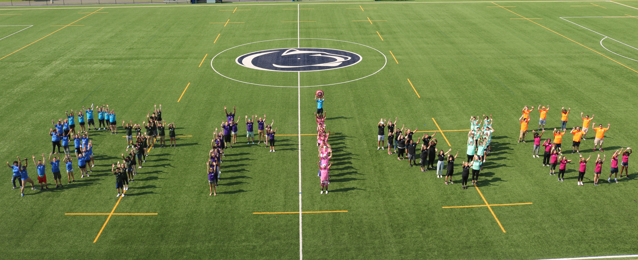
FALL 2019 SEMESTER, I PLAN TO LIVE:
___On campus
___Off campus at home ___Off campus not at home
If you are planning to live off campus, how long will your commute be?

Include ALL Social Media Names/Handles
(Include: Facebook, Twitter, Instagram, Snapchat):

SELECT WHICH TYPES OF OL YOU WOULD BE INTERESTED IN:
See attached expectations for more information

____Serving as a Color Team OL ____Serving as a First Year Group Leader (FYGL)

Serving as a Mover and Shaker ____Serving as an Operations OL (OPPs)

IN THE SPACE PROVIDED, OR ON A SEPARATE SHEET, PLEASE ANSWER THE FOLLOWING:
- Why do you want to be an Orientation Leader again?
________________________________________________________________________________________________________________________________________________________________________________________________________________________________________________________________________________________
- What advice do you have for First Year OLs?
________________________________________________________________________________________________________________________________________________________________________________________________________________________________________________________________________________________

- What type of information would you like covered during Returner Training?
________________________________________________________________________________________________________________________________________________________________________________________________________________________________________________________________________________________
- What would you like to see improved from your last experience as an Orientation Leader?
________________________________________________________________________________________________________________________________________________________________________________________________________________________________________________________________________________________
- What is one word you would use to describe your Orientation experience?
________________________________________________________________________________________________________________________________________________________________________________________________________________________________________________________________________________________
Please initial next to each statement:
____ The information that I have provided on this application is accurate and true to the best of my knowledge.
____ I understand that incomplete or inaccurate information may be grounds for disqualification from the Orientation process.
____ I authorize Campus Life to regularly review my academic and disciplinary records recognizing that this could impact my ability to continue in the Orientation Leader process.
____ I authorize the Welcome Weekend Leadership team to regularly review my social media presence, and understand this could impact my ability to continue in the Orientation process.
____ I have reviewed all expectations of Orientation Leaders and plan to uphold them all.
____ I have reviewed all dates for necessary trainings and will be in attendance. If I am not able to do so, I will notify Lead Team and/or Autumn at least 2 weeks prior.

Signed _____________________________________________________________ Date____________________

Return this application by March 1, 2019 at 5 p.m. to the Campus Life Office in 19 Perkins Student Center
Thank you for your interest in being an Orientation Leader. If you should have any questions concerning this application or about the responsibilities of an Orientation Leader,
please contact Autumn Fritz (amr40@psu.edu) or stop by the Campus Life Office or call 610-396-6076.

