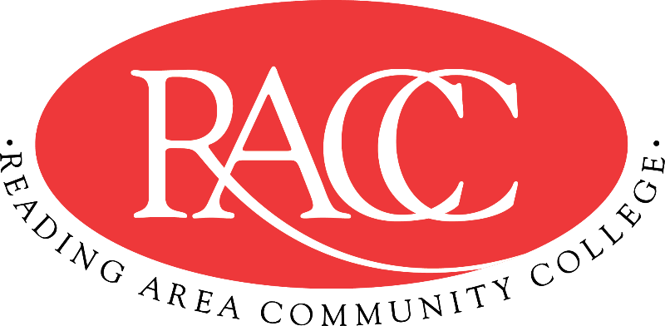

Transfer Guide
Reading Area Community College & Penn State Berks
A.A. in Addiction Studies/ Human Services |  |  | B.S. in Rehabilitation and Human Services
Course | Name | CR | Equivalent Course/ Area Satisfied | CR
CSS 103 | College Success Strategies | 3 | 3 cr. PSU xfrGEN | 3
COM 121 | English Composition I | 3 | ENGL 15 (GWS) | 3
COM 151 | Fundamentals of Speech | 3 | CAS 100 (GWS) | 3
COM 221 | English Composition II | 3 | ENGL 202B | 3
IFT 110 | Microcomputer Applications | 3 | MIS 204 | 3
Total Credits |  | 15 | Total Credits | 15
PHIL 271 | Introduction to Philosophy | 3 | PHIL 1 (GH) | 3
PHIL 275 | Introduction to Ethics | 3 | PHIL 103 (GH) | 3
ENV 130 | The Environment | 3 | General Education: Natural Sciences (GN) | 3
BIO 130 | Human Biology | 4 | BISC 4 + 1 cr. BISC xfrGN0 (GN) | 4
PSY 130 | General Psychology | 3 | PSYCH 100 (GS) | 3
Total Credits |  | 16 | Total Credits | 16
SOC 130 | Sociology | 3 | SOC 1 (GS) | 3
PSY 208 | Development Across the Lifespan | 3 | PSYCH 212 (GS) | 3
ADD 105 | Drugs & Alcohol in American Society | 3 | BBH 143 (GHW) | 3
PSY 230 | Abnormal Psychology | 3 | PSYCH 270 | 3
HMS 105 | Professional Helping | 3 | 3 cr. RHS xfrGEN (Elective) | 3
Total Credits |  | 15 | Total Credits | 15
MAT 210 or MAT 150 | Statistics or Foundations of Mathematics | 3 | STAT 100 (by Substitution) or 3 cr. MATH xfrGQ1 | 3
HMS 106 | Group Facilitation | 3 | 3 cr. RHS xfrGEN (Elective) | 3
HMS 205 | Case Management | 3 | 3 cr. RHS xfr200 (Elective) | 3
ADD 205 | Addiction and Recovery | 3 | 3 cr. PSYCH xfrGS1 (Elective) | 3
PSY 226 | Counseling Theories | 3 | 3 cr. PSYCH xfrGS2 (Elective) | 3
Total Credits |  | 15 | Total Credits | 15
Total Credits |  | 61 | Total Credits Transferable | 61

This Transfer Guide is designed for Penn State Berks ONLY. Students seeking transfer admission to any other campus should contact that campus directly.
This Transfer Guide may change without notice before the student is admitted to Penn State Berks. RACC students should confirm their academic plans with the Transfer Admissions Counselor at Penn State Berks: 610-396-6462 or berkstransfer@psu.edu. Following this Transfer Guide does not guarantee admission or transfer of credit to Penn State Berks.

