Online Quizzes and Homework for a Matlab Programming Course
Dr. Joseph M. Mahoney
2018

Introduction

This aim of this project was to create online, automatically-graded assignments for CMPSC 200: Matlab programming for Engineers. These assignments were in two forms: (1) a quiz within Canvas to test fundamental concepts from a new topic and (2) online homework assignments in MathWork’s Cody Courseware to test students’ programs.

The instructor offers the course in two forms: a completely online format in the summer and a “flipped classroom” format in the spring semester. In both versions, lectures and example problems are delivered via online videos created by the instructor. In the online course, students can interact directly with the instructor via Zoom or email. The spring semester version requires students to attend two 75-minute “open labs” per week to work on their homework and projects with the instructor available for assistance.

Quizzes were aimed to test students’ foundational knowledge of a new topic after they watched the required videos. Quiz questions had students predict the result of small blocks of code, choose the right syntax to implement a new function and write small programs. These quizzes were designed to act as a gatekeeper to ensure students have enough base knowledge to attempt the more complicated homework problems. Students have up to three attempts at the Quiz with their grade determined by the score on their last attempt.

The online homework via Cody Courseware was created to give students instant feedback on their code. Previously, students would submit their code one time to the instructor for grading. If a student needed help, they would have to come to office hours or try to communicate through email. Cody will instantly, and at any time of day, let students know if they did the problem correctly. The system compares the code written by the student to the correct code written by the instructor. The outputs of both codes are displayed to the student. Students are given unlimited attempts to test their code against the correct version. The system is free for the students to use and can be accessed from any browser, even if the computer does not have Matlab installed. The system does, however, require the instructor to create all content.

Project Design

The Canvas Quiz section required creating new questions and programming them into Canvas. Some questions rely on data files that are posted to Box. Eight quizzes were created for this project, each one typically containing five to eight questions. An example Quiz question is shown in Fig. 1.

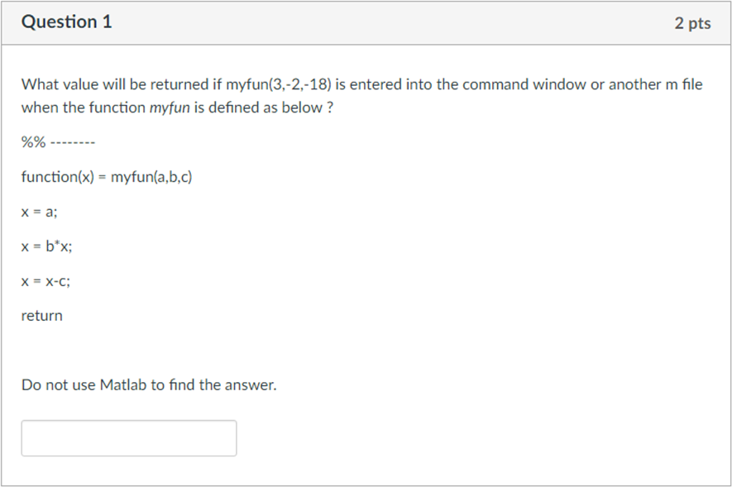
Figure 1: Screenshot of typical Canvas quiz question. Here, students are to calculate what Matlab should return from the given function.
For the Cody portion of the project, most questions came from those assigned in previous semesters, but they had to first be translated into the Cody System. This required setting up a “correct” code that the system checks the student solution against. It also requires a template for the students to begin working with. Finally, it requires code to run to test to the two solutions against each other. Seven homework assignments were created in Cody, each one with three to six questions. An example Cody question and user interface is shown in Fig. 2.

Most of the questions in Cody were used as a starting point for written part of homework assignments. In this second part, students used their code to make plots and calculate results from given inputs. They then wrote a formal submission of their methods, results and discussion.

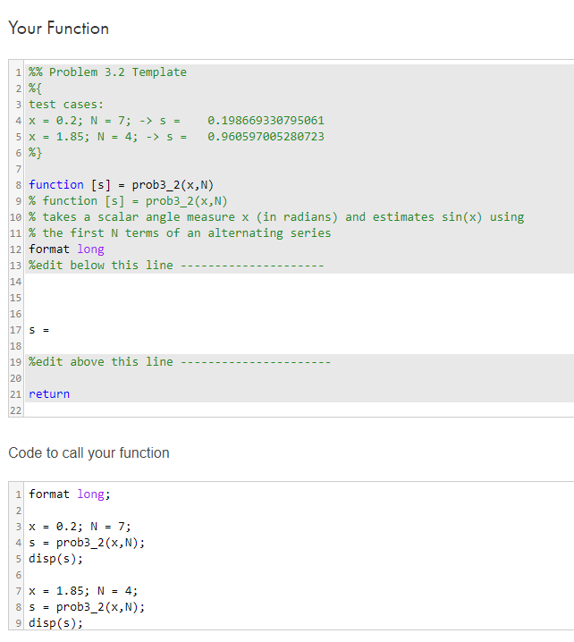
Figure 2: Screenshot of typical Cody question. Students enter their code into the white (unshaded) section of the top entry. They then run their code in the bottom block.

Learning Outcomes

To measure and assess several outcomes related to the project, an online survey was offered, via Qualtrics, to students during finals week. Students were emailed the link to the questionnaire and informed that their choice to participate would not impact their grade. Additionally, if they chose to complete the survey, their responses would not be read until grades were posted and would have no bearing on their grade.

The survey included three sections of questions. Students responded to prompts on a seven-point agree/disagree Likert scale. The questions about online videos are listed in Table I, Canvas Quizzes in Table II and Cody Courseware in Table III. Boxplots of the student survey results are shown in Figs. 3-5.

The survey was completed by $n=7$ students. The mean value of each response was compared to “4,” the neutral response, by using bootstrapping with 1 million resamples. The significance threshold was set a priori to $p=0.05$.

For all boxplots, stars denote the significance level of the mean response being greater than “4” as one star indicates $p<0.05$, two stars indicate $p<0.01$ and three stars indicate $p<0.001$. The red central line is the median response and the boxes are the 75th and 25th percentiles. Whiskers extend to the upper and lower range of data. Red crosses indicate outliers, but all data is included in the significance analysis.

Table I: Survey questions about online video
V1 | The online videos helped me learn content for the course
V2 | Each video was short and focused to convey a topic or example of the lecture
V3 | The number of videos per lecture was appropriate
V4 | *For this course*, I feel that watching lecture videos were as useful as an in-class lecture
V5 | The ability to review sections of video helped me when completing assignments

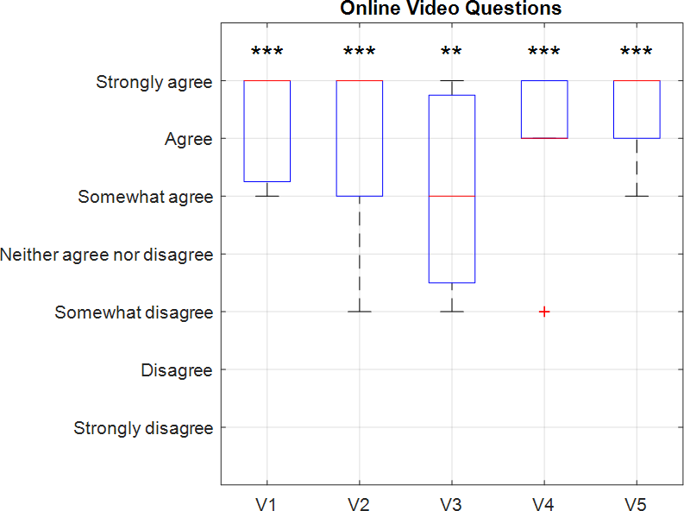

Figure 3: Boxplot of video question responses

Table II: Survey questions about Canvas Quizzes
Q1 | I was able to complete the quizzes based on the information and examples from the videos
Q2 | The Canvas Quizzes prepared me for starting the homework assignments
Q3 | The Canvas Quizzes tested my fundamental knowledge of each section’s topic
Q4 | The Canvas Quizzes aligned with proposed objectives, so I know where the course is going
Q5 | The Canvas Quizzes helped me achieve the course learning objectives

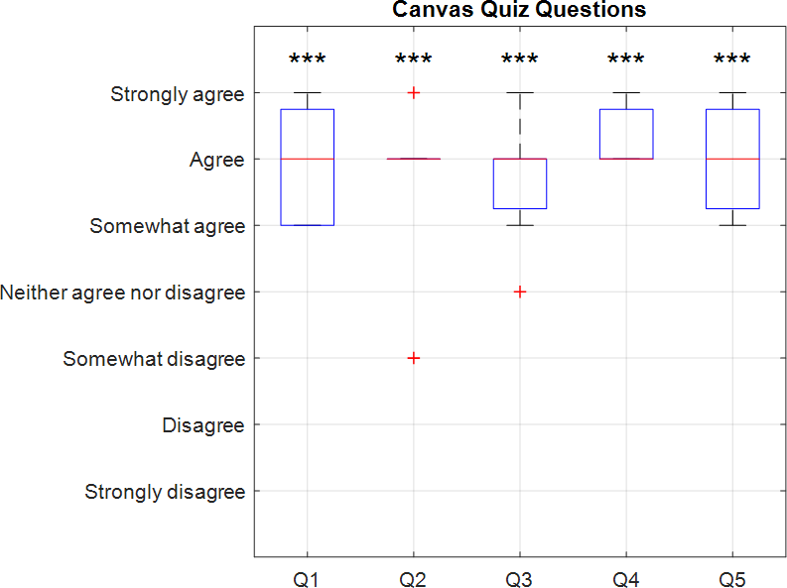

Figure 4: Boxplot of Canvas quiz question responses

Table III: Survey questions about Cody
C1 | Cody helped me learn to code
C2 | Cody was frustrating to use
C3 | Cody made my grade better
C4 | Cody gave me feedback to improve my code
C5 | The Cody environment was easy to navigate
C6 | The Cody environment increased my interactivity with the course content
C7 | Submitting my code on Cody was easier than uploading to Canvas
C8 | The homework problems aligned with the course objectives, so I know where the course is going
C9 | The Cody homework problems helped me achieve the course learning objectives

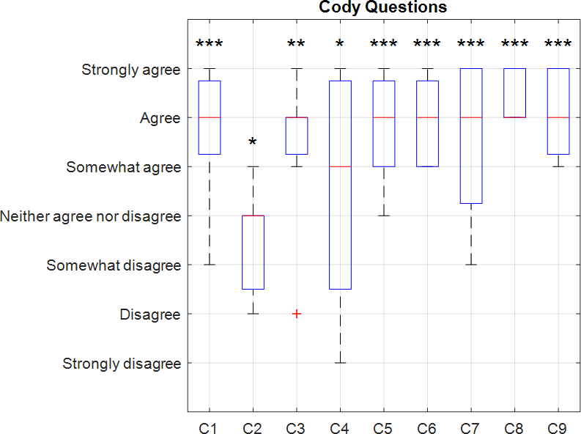

Figure 5: Boxplot of Cody question responses
Discussion

Online Video
Students generally agreed with all prompts in this section. The question with the least positive response was “The number of videos per lecture was appropriate.” In retrospect, the question was not well posed as it is unknown if the students felt there were too many or too few videos per topic. For now, it is assumed that there were too few videos available as students have the option to simply skip videos they do not need to complete the material. In future offerings, an extra video or two per topic can be added to give more detail to less-covered aspects of the topic.

Canvas Quizzes
Students generally agreed with all prompts in this section. The median response to each prompt was “Agree.” The addition of the Canvas quizzes met its goals on acting as a check on students watching the videos and understanding them enough to then being the homework assignment.

Cody Courseware
Students generally agreed with all prompts in this section. The least positive response was given to Cody giving useful feedback to improve their code. Students were split on Cody being frustrating to use. First, the next time the course is run a sample assignment in Cody can be added for the students to try so that they can learn the system in a low-stakes environment. Also, a document showing students how to use the feedback from Cody will be added. Without this, it is not necessarily obvious how to check code and see the results after submission.

Note the response size to the survey was small, but students were not offered an incentive to complete the survey. Despite the low sample size, statistical significance of the difference in means was found for all prompts.

Scholarly Outcomes

IRB permission was not received for these surveys and the participation numbers were small. This work will be used as part of a larger project in the fall to assess the effectiveness of teaching Matlab as a first programming course.

Recommendations

As presented in the discussion, some future improvements and additions may remedy the least positive results from the survey. Instructors of this course at the Berks campus will be invited to use the Cody homework and Canvas quizzes in their sections. They will be asked to administer the survey to their students after the course to increase the sample size.
Conclusion

The Canvas quizzes were well received by the students. Addressing the fundamental questions in the quiz seemed to help the students begin the homework. Anecdotally, fewer “simple” questions were noticed when helping students one-on-one in open lab. Additionally, the ability to look back at the videos meant that students were often able to find the answer they would have asked.

Implementing the Cody Courseware system was successful. Students overall thought that the system helped them learn to code and liked that they were able to receive some immediate feedback on their solution. It definitely saved the instructor time on grading. Furthermore, the system required a correct answer to receive credit for the problem. No partial credit was awarded. Students used their solution from Cody in the second part of the homework which was submitted with a write-up. They knew that their base code was correct before moving to part two.

Acknowledgments

Thank you to Hongyan “Red” Yuan for her support on implementing the project and writing the survey questions.

The mean response for question C2 was tested for being less than 4

