TLI Grant Report

“Creating and Editing a Professional-Quality Podcast in English 211W”

Christian Weisser

Summer and Fall 2017

INTRODUCTION
In early 2017, the Professional Writing faculty began an “update” on the Professional Writing major at Penn State Berks. One of our primary goals in that update was to add more multimedia projects into the curriculum. Our faculty identified English 211W: Introduction to Writing Studies as a target for more multimedia work, since that course is a gateway course in the major and is required of all majors and minors as they enter the degree program. As such, it should incorporate the PW major’s Program Learning Goals, including “addressing literacy across a range of print and electronic genres.” However, our faculty recognized that the course did not sufficiently address AURAL Literacy: the creation and delivery of the spoken word. Much of the recent research in our field addresses “sonic rhetoric” and aural literacy, yet we had not integrated this development into our courses in a meaningful and innovative way.

To this end, I determined that I should implement Podcasting as a focal point in the gateway ENGL 211W course. As the faculty member who currently teaches the gateway course, I recognized that I must study existing scholarship on aural literacy, learn the appropriate technologies to integrate podcasting into this course, and design innovative strategies to facilitate student learning. While the creation of a simple podcast may be straightforward, the faculty member who teaches this subject to our professional writers must be able to do so in a scholarly, rigorous, and sophisticated way, which those students could go on to use in their professional lives—no small task. In recent years, professional podcasts have emerged as an important communication genre in nearly every facet of professional life, and many businesses employ professional writers to create scripts, record podcast episodes, and edit audio tracks.

Consequently, I applied for a TLI grant in Spring 2017 to obtain the support and time necessary to integrate podcasting and aural literacy into our gateway English 211W course. The broad goal was to create an assignment where each student would research a topic, then create a podcast as part of a series completed by the class. Typical enrollment in this class is 15-18 students, so we anticipated a collection of 15-18 podcasts at the end of the semester.

STAGES OF THE GRANT PARTNERSHIP
This grant partnership incorporated the following stages and activities:

Stage 1 (May and June 2017): Meetings with Hongyan (Red) Yuan, Daonian Liu, and Mary Ann Mengel to plan the various goals, assessments, and outcomes associated with this project. Researching appropriate technologies, learning theories and scholarship behind aural literacy, learning necessary pedagogical and technical skills in the creation of podcasting.

At this point we determined the topic/focus of the podcast: student reflections on a “misconception” or misunderstanding about writing. This gave students a clear purpose and provided a hypothetical audience of first-year writing students who may be interested in the topic.

Stage 2 (July and August 2017): Regular meetings with Red Yuan to track progress and develop materials. Creating instructional materials for students, including a sample podcast model designed as the “introduction” to the podcast series that students would create; developing pre and post surveys to determine student learning of aural literacy through podcasting assignments; creating assignment handouts and other ancillary materials. At this point I also began discussion and planning with Carla Seward, who would go on to lead student workshops in GarageBand software for recording podcasts.

Stage 3 (September and October 2017): Regular meetings (in person, by phone, and through ZOOM videoconferencing) with Red Yuan to track progress and consider course integration strategies. Integrating assignments into English 211 coursework; working with CLT team and TLT Media Commons traveling consultant Carla Seward in delivering presentations and instruction to students; working with students in revision and editing of their podcasts, both in script form and in the audio files created in GarageBand. We chose a free audio tune from Jamendo to use as our intro music, which creates a “series” aspect to the podcasts rather than individual shows. Further, we collectively created a name “The Truth about Writing” as well as a short introduction to add further consistency.

Stage 4 (November and December 2017): Follow-up meetings were held with Red Yuan to finalize assessment strategies and develop surveys. Students finalized their projects and submitted them through Canvas as MP3 files. I assessed student podcasts through pre and post surveys; provided written and aural feedback on student work; and assessed the overall proficiency of students who have completed the assignments (leading to 20% of final course grade). As a final stage in the assignment, we listened to all student podcasts in our class, analyzing the strengths and weaknesses of each podcast, in terms of content and writing as well as audio production and editing. Students then wrote a reflective blog entry about their experiences with podcasting.

LEARNING OUTCOMES
Students in ENGL 211W were assigned a pre and a post survey along with the podcast project. The primary goal was to track students’ experience and familiarity with podcasting, and to determine if perceived experience level and familiarity with podcasts improved or increased through the assigned course project. The following questions were included in the pre and post surveys, which were administered through Canvas:

Pre Podcast Survey
- What is your level of expertise in creating podcasts? (novice, minimal experience, moderate experience, expert)
- What is your level of interest in creating podcasts? (no interest, some interest, a lot of interest, highly interested)
- Do you listen to podcasts on a regular basis? (Y/N)
- If you answered YES to #2, which podcasts do you listen to? (open answer)
- What are your expectations or perceived challenges in creating a podcast for this assignment? (open )
- What do you think are the important characteristics of an engaging and professional Podcast? (open answer)
- Do you think you’d enjoy creating podcasts as part of your professional duties in your career? (open answer)

Post Podcast Survey
- What is your current level of expertise in creating podcasts? (novice, minimal experience, moderate experience, expert)
- What is your level of interest in creating podcasts? (no interest, some interest, a lot of interest, highly interested)
- Do you think you will listen to podcasts more often as a result of this assignment (Y/N)
- Are there any podcasts you’ve been exposed to through this assignment that you will continue to follow?
- What are your expectations or perceived challenges in creating a podcast for this assignment addressed? Were there unforeseen challenges you did not expect, and how did you address them? (open )
- What do you think are the important characteristics of an engaging and professional Podcast? (open answer)
- Did you find the assignment intellectually challenging and stimulating? (Y/N)
- Do you think you’d enjoy creating podcasts as part of your professional duties in your career? (open answer)
- Do you have any general comments or suggestions regarding the podcast assignment?

All 15 enrolled students completed both the pre and post assignment surveys. Consequently, I have a wealth of data to analyze—far too much to address in this survey. I am considering writing a full-length scholarly article about this project that would incorporate all of the data. For the purposes of this report, I will highlight questions #1, and #2 in both podcasts, since they are similarly structured and address the important questions of expertise (perceived learning) and interest. See the details below.

Question #1, Pre Assignment
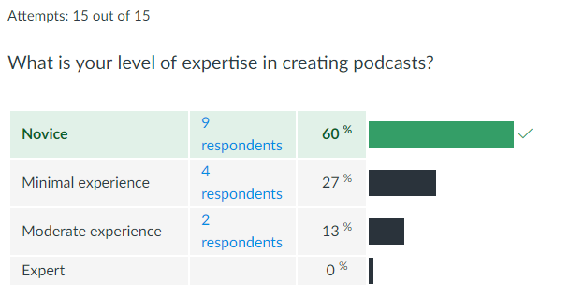

Question #1, Post Assignment
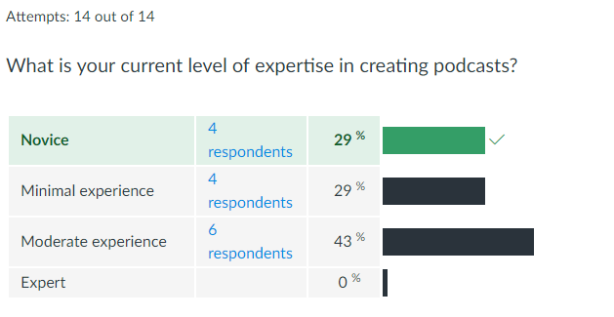

Question #2, Pre Assignment
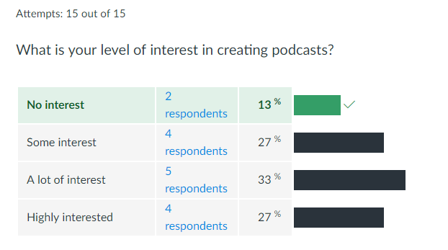

Question #2, Post Assignment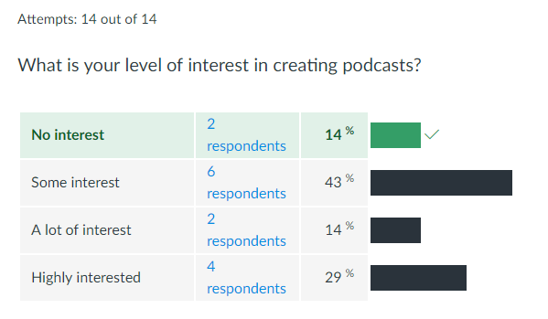

Data Analysis
As the data in Question #1 indicates, student perceptions of expertise in creating podcasts rose dramatically as a result of this assignment. At the outset, 60% of students reported themselves as “novices,” while that number was cut in half to 29% of students self-assessing as novices after the assignment. Similarly, the numbers of students reporting as having “moderate experience” rose dramatically from 13% to 43% pre and post assignment.

The data in Question #2 is equally compelling, since it assessed students’ level of interest in creating podcasts. Student level of interest in creating podcasts remained high pre and post assignment. Prior to the assignment, 87% of students reported some, a lot, or high interest in creating podcasts. After experiencing the challenges of writing, recording, and editing a podcast on their own, the interest level remained high with 86% of students reporting some, a lot, or high interest in creating podcasts. In other words, more than ¾ of PW students remained interested in podcasting through this project.

Other questions in the pre and post surveys reveled general satisfaction with the assignment itself, an interest in listening to more professional-quality podcasts, and an appreciation for the help and guidance they received from their instructor, from the TLT staff, and from peer reviewers.

The assignment met the primary Learning Goal objective of “addressing literacy across a range of print and electronic genres.” For many students, this was the first “sonic” or aural project they had to complete, and as such it expanded Professional Writing students’ familiarity with multimedia. The project revealed interesting differences between the written and spoken word, and students discussed, analyzed, and practiced methods to transfer effective communication to this new platform, including key concepts of repetition, vocalization and tone, and the use of visually-oriented examples.

Similarly, the structure of this project allowed students to create a professional-quality podcast—not just a simple audio recording. The various stages of script writing, recording, and editing facilitated a process approach similar to that of professional podcasting. In addition, the use of a pre-selected format, the serialized nature of the podcasts, the background soundtrack, the predetermined length and content, as well as a required expert interview all contributed to the professional quality of the assignment. In short, this project included all of the features a student might be asked to replicate if they worked as a professional podcaster.

At the same time, student comments reflected many of the more traditional qualities of effective communication encapsulated in the assignment. These provide qualitative evidence of meeting the learning objectives of the course. Students in the post-survey reported the value of “knowing your audience,” presenting information “in a concise manner,” and a “strong and profound voice.” Other students reported the following:

"At first I was put off by the assignment. It seemed like an added layer of complexity with the podcast. However, upon its completion, I ended up enjoying the creation of the podcast. It added a very creative vibe."
"The characteristics of an engaging and professional podcast is a good tone and pace."
"As I said before, while scripting is important, you do not want to seem as you're reading every word. Scripts should guide, but not dictate, the podcast (in my opinion). The listener does not want to be read 'at', they want to be spoken to (if that makes sense). Even though the listener is not with you personally, you want to make them feel as if they are involved with the podcast in some manner, you want to keep the audience engaged."

Consequently, the assignment expanded students’ fundamental understandings of rhetoric and persuasion while exposing them to a new genre and platform for delivering content.

Conclusion
The TLI grant and accompanying support from the CLT was extremely helpful. Without the grant, I would not have undertaken such a huge project on my own, especially one that involved a genre that was relatively new for me. I especially appreciate Red Yuan’s diligence in keeping this project on track, as well as her help in designing assignment handouts and the pre and post surveys on Canvas. I also appreciate Carla Seward’s excellent “demo” of the GarageBand software. Most students used this software upon her recommendation, and that made the project much more manageable.

Although I have not yet seen the SRTE scores from fall semester, the survey results and my overall impressions of the assignment lead me to believe this podcast project was a success for students, for me as the instructor, and for the Professional Writing program. I will continue this project next Fall semester, when I next teach English 211W: Intro to Writing Studies.

