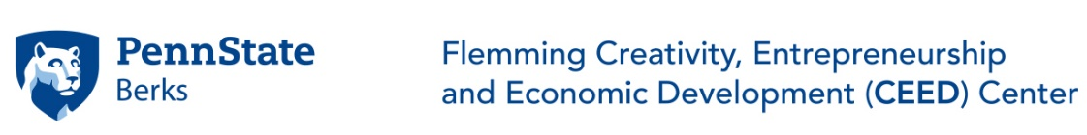
In an effort to inspire an entrepreneurial spirit among students and to seek partnerships with business and industry that foster economic growth for the local community, Penn State Berks–along with all of Penn State University- is celebrating Global Entrepreneurship Week, November 11-15, 2019
Students with disabilities are welcome at this event. Contact Dr. Kulturel (sadan@psu.edu) with questions or special needs.
Monday, November 11  10:30AM-2:30PM  Thun Library 145 | Creativity & Entrepreneurship Workshop  Guests: Reading School District Students
Tuesday, November 12  1:35PM-2:50PM  Gaige 245 | Topic: “Financing Startups”  Speaker: John Gotta, CEO, JGO Services
Wednesday, November 13  12:15PM-1:15PM  Gaige 121 | Entrepreneurship Speaker Series  Topic: “Women Entrepreneurs of Berks County”  Speakers: Lindsay Sokol Szejko, Owner, SOLO Laboratories, Inc.  Jaimyn Westenhoefer, President, SOLO Laboratories,  Inc.  Natalie Parisi, Owner, ROG Orthodontics  Alma Vasquez, Owner, YAVE Investments LLC and  Pagoda Café
Thursday, November 14  4:30-5:30PM  Gaige 249 | Topic: “Modifying a Product Design for the EU Market”  Speaker: Randy Saylor, Partner, Teq Group
Thursday, November 14  5:30-7:30PM  Gaige 248 | Topic: “Workshop on Design Thinking”  Speaker: Sadan Kulturel-Konak & Abdullah Konak  Complete the form https://forms.gle/8itCFVQuL7dv7XdK8 to RSVP
Thursday, November 14  6:00PM-6:45PM  Gaige 245 | Topic: “Business Development for European Companies in the  US- Challenges and Opportunities”  Speaker: Jochen Hager, Business Development Executives LLC
Thursday, November 14  6:00PM-6:45PM  Gaige 121 | Topic: “How a Small Entrepreneurial Manufacturing Company  Competes in the Global Market”  Speaker: Randy Saylor, Partner, Teq Group
Sadan Kulturel-Konak. PhD:
Professor, Management Information Systems
Director, Flemming CEED Center
Students with disabilities are welcome at this event. Contact Dr. Kulturel (sadan@psu.edu) with questions or special needs.

