Online Companion for BIOL 230W Lab

Bryan Wang

Design: Spring–Summer 2016
Implementation: Fall 2016
Analysis and Final Report: Spring 2017

Introduction

BIOL 230W is a core course in the biology curriculum. The BIOL 230W lab component (one credit, two classroom hours per week) includes pre-class reading; experimental bench work and classroom discussions; and post-lab writing assignments. Previously, I used manuals supplied by the various manufacturers of the laboratory kits for the background reading and protocols. Since these resources were provided in pdf format (some as scanned images), they imposed accessibility challenges and required printing for optimal viewing. Furthermore, they represented a scattershot collection, varying in breadth, depth, and age of content as well as style and format. This TLI Grant project replaced these materials with a customized online companion that guided students through the course using a “digital workflow,” with the goals of increasing student engagement and learning, enhancing accessibility, and supporting sustainability efforts on campus.

Project Design and Implementation

The online companion consists of weekly learning modules in Canvas that replace the pdf format, manufacturer-supplied manuals with pre-lab reading assignments and content pages that function as classroom workbooks. I also imported existing post-lab assignments into Canvas.

Pre-Lab Assignments

In the updated course, students work in Canvas before class to gain background knowledge and prepare for in-class discussions and bench work. I integrated pre-class reading material—which may include illustrations and videos as well as text—along with embedded questions into a Canvas quiz (using the “text no question” option in Canvas to present the reading material). By combining instructional content with quiz questions, we hoped to create a more interactive experience for students and to increase retention by encouraging the reader to pause periodically for reflection. The text and some figures were adapted, with permission, from the manufacturer-supplied manuals.

Classwork

Lab periods pair classroom discussions with experimental work completed in groups of two or three students. The new online workbooks guide the students’ efforts at the bench and house a record of their work. The workbooks include customized protocols for each laboratory exercise; space for general notetaking during class discussions and lectures; workspaces for recording and analyzing data (in tables, Excel graphs, digital photos, etc.); and focus questions and space for responses.

I created templates of each workbook as Canvas content pages. During class, groups copy the appropriate template into a new page in their Canvas group space, complete the workbooks collaboratively, and submit the URL of the completed workbook as a group assignment in Canvas. Students use laptop computers (personal or university-owned) at the bench throughout the period.

After class, the instructor grades the workbook, providing feedback as summary comments and/or by editing the page with text presented in a distinctive font for emphasis.

Lab Review Assignments

Following each laboratory period, students complete post-lab writing assignments to review and build on their understanding of the experiments and to refine their scientific writing skills. These assignments include short essays (“microthemes”) and, in the first half of the semester, individual sections of a formal lab report. In the second half of the term, students draft and revise a full lab report that documents their work in a multi-week series of experiments.

Students submit writing assignments through Canvas and the instructor grades through SpeedGrader, with feedback offered through summary comments and Crocodoc annotations.

Outcomes

To measure student perceptions of the online companion and the updated course, an anonymous survey was administered through Qualtrics during the 11th week of the Fall 2016 semester. A similar survey administered through ANGEL in the 8th week of Spring 2016 (before implementation) provided a baseline measure of attitudes.

Likert scale evaluations in the survey revealed enthusiasm for the updated materials and format. For instance, students unanimously agreed: (1) that the “pre-class readings and quizzes are valuable to learning” (see Figure 1); (2) that the lab workbooks help them “stay focused on experiments and engage with the material in class,” “aid collaboration among students,” and “are valuable to learning”; (3) that “having all of the course materials, submissions, and feedback in Canvas is helpful”; and (4) that it’s “convenient and engaging to work digitally.”

Written comments reinforced these themes. About pre-class assignments, survey respondents wrote, “I come into lab ready to start without any confusion” and “pre-class quizzes… get us thinking rather than just skimming over the procedure.” The in-class workbooks were “easy to use and very efficient” and “highly beneficial in keeping us on task and reinforcing the learning objectives.” Students also came to appreciate the electronic nature of the course, saying, “At first I was a little hesitant towards [how everything is online] but I really liked working this way” and “I have really come to enjoy the ability to perform our work digitally.”

The course update also appears to have improved engagement with pre-existing course materials that were simply migrated to Canvas during the update—students were more likely to judge the in-class lectures and discussions, the bench work, and the summative written assessments (microthemes and lab reports) valuable than in the previous semester (Figure 1). Students found the admittedly low-tech (chalkboard) lectures in class “valuable” and “beneficial”; they also commented on the online grading and annotation features of Canvas, with one student writing, “having feedback… really helped my writing techniques” and another declaring, “Feedback rocks!” (In previous semesters, I provided similar feedback, somewhat less conveniently to the students and to me, using the Microsoft Word commenting feature in files uploaded in ANGEL dropboxes.)

The improved satisfaction with pre-existing learning activities suggested that the updated course better supports learning. Indeed, the surveys showed that, following the redesign, students found the course workload more manageable and judged the difficulty of the course easier (Figure 2), and final lab grades were higher than in previous semesters. Thus, the online companion and workflow may offer an opportunity to enhance the learning experience with more challenging content.

Students also maintained a positive impression of the course as a whole. In Spring 2016, students judged the course “good” (29%) and “very good” (71%). In Fall 2016, after the redesign, 5% judged the course “moderate”; 8%, “good”; and 87%, “very good.” In SRTEs, the overall quality of the course was rated 6.89 in Spring 2016 and 6.71 in Fall 2016.

Student Agreement with Assertions on the Value of Various Learning Activities

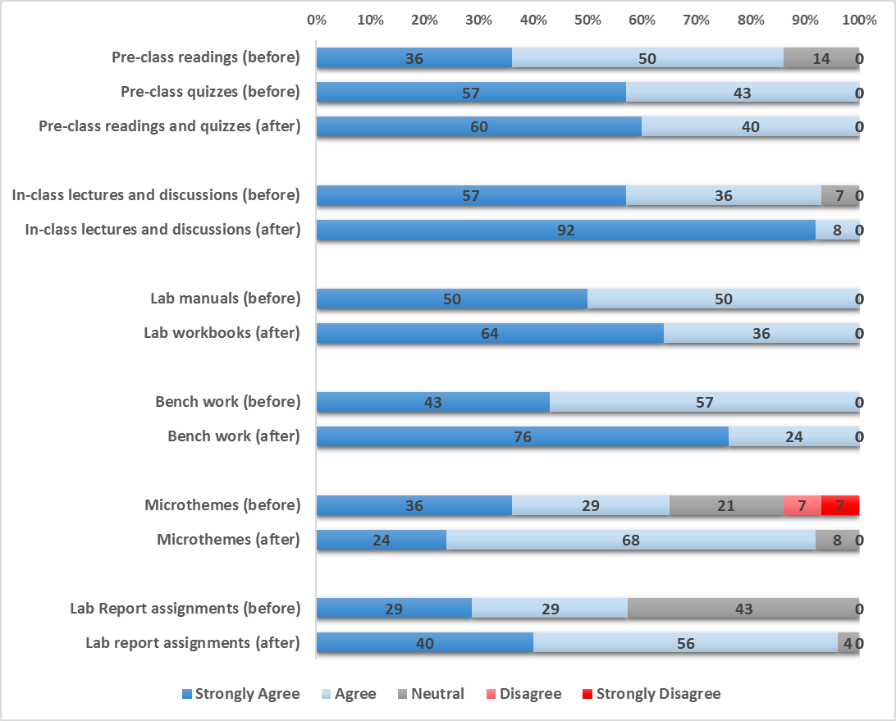

Figure 1. Mid-semester surveys of students’ perception of the value of various course learning activities, before (Spring 2016) and after (Fall 2016) implementation of the digital workflow. Reported are the percentage (rounded to the nearest percentile) of students in various levels of agreement with the statement “The [stated learning activities] are valuable.”

Student Evaluation of the Pace, Workload, and Difficulty of the Course

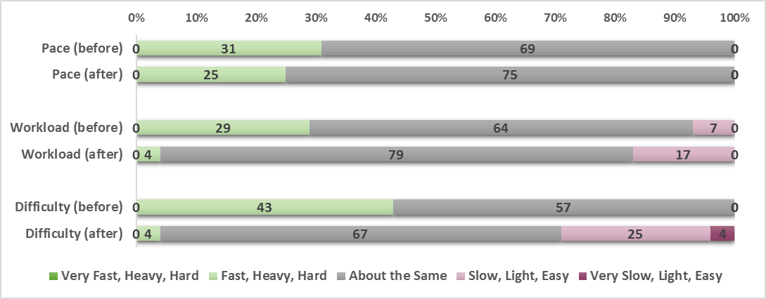

Figure 2. Mid-semester surveys of students’ perception of the pace, workload, and difficulty of the lab course before (Spring 2016) and after (Fall 2016) implementation of the digital workflow. Reported are the percentage (rounded to the nearest percentile) of students responding in the indicated manner to the statement “The [parameter] of this lab, relative to comparable labs, is. . .”

Discussion

I compiled an online “companion” and implemented a digital workflow into the BIOL 230W laboratory, a project initially motivated by the desire to update the lab manuals and leverage the Canvas LMS to address accessibility and sustainability concerns. The update also has improved the learning experience and student satisfaction. Students expressed enthusiasm for both the new materials and pre-existing learning activities migrated into the new course, and they have embraced the electronic format.

Familiarizing students with such a format may itself amount to an important goal. By exploiting the Canvas group space, the lab workbook encourages collaboration in (and out of) the lab. Furthermore, students use a variety of computer applications—spreadsheets, digital photography, graphing and linear regression—and develop data curation skills that will take on increasing importance as electronic laboratory notebooks (eLNs) permeate educational (Johnston 2013, Weibel 2016) and standard lab practice (Giles 2012). (This term, students in BMB 445, a molecular biology lab course at Penn State Berks, are exploring the use of eLNs.)

In providing a stable, structured framework for pre-lab preparation, in-class discussion and bench work, and post-lab reflection and assessment, the online companion and digital workflow benefits both instructor and student. The architecture should facilitate transferability across sections of the same course and between instructors. In addition, one may readily adopt the strategy in other laboratory courses, especially the high-enrollment, lower-undergraduate laboratory courses that feature more directed, prescribed investigations, and thereby expose more students to the advantages of blending online learning and hands-on practical work.

Acknowledgements

I thank Mary Ann Mengel for guidance throughout the project; Amy Roche for guidance in early phases of the project and instrumental work in obtaining copyright permissions; Daonian Liu for help with the initial proposal; and Maureen Dunbar, Pradip Bandyopadhyay, and Paul Esqueda for the opportunity to work on this TLI grant project.

Literature Cited

Giles, Jim. "The Digital Lab." Nature 481.7382 (2012): 430.

Johnston, Jill, et al. "Using an ePortfolio system as an electronic laboratory notebook in undergraduate biochemistry and molecular biology practical classes." Biochemistry and Molecular Biology Education 42.1 (2014): 50-57.

Weibel, Jason D. "Working toward a Paperless Undergraduate Physical Chemistry Teaching Laboratory." Journal of Chemical Education 93 (2016): 781-784.

